Final Project Setup

*If you have not created a Watson service before proceed with Step 1, otherwise go to Step 2:*

**Step 1: For New Users (with no Watson service):**

For this project, you will use your IBM Watson Studio account from the previous chapter.    
  
Go to the IBM Cloud Watson Studio page:

[Click here](https://cocl.us/cc_python101_pandas_Watson)

You will see the screen in the figure below. Click the icon in the red box:

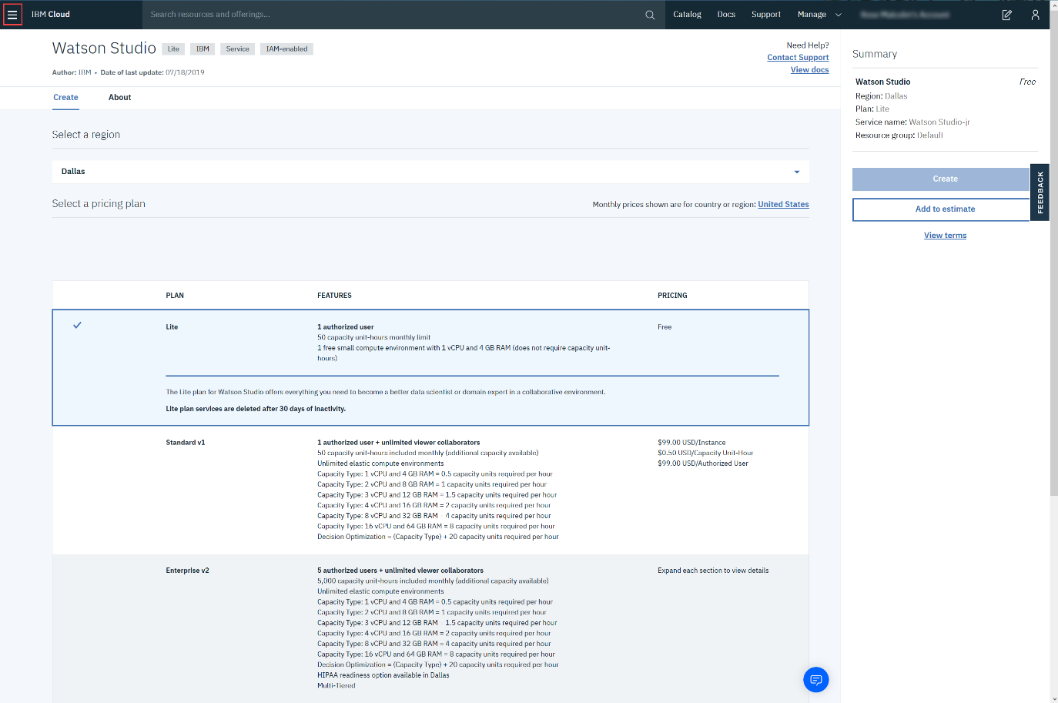

Then click **Watson**, as shown below:

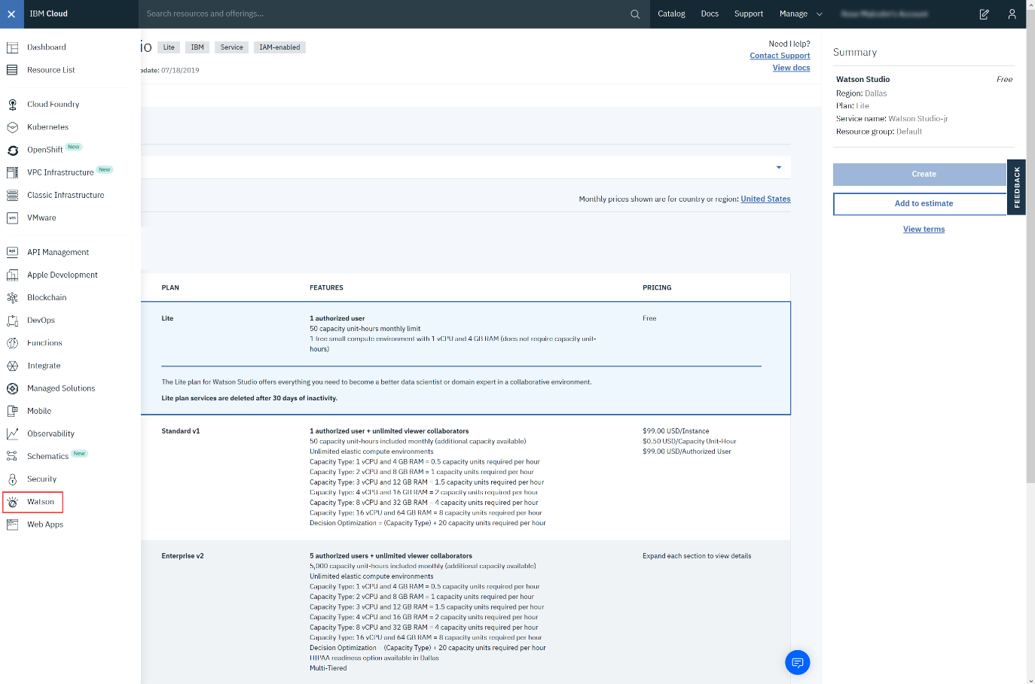

Then click **Browse Services**.

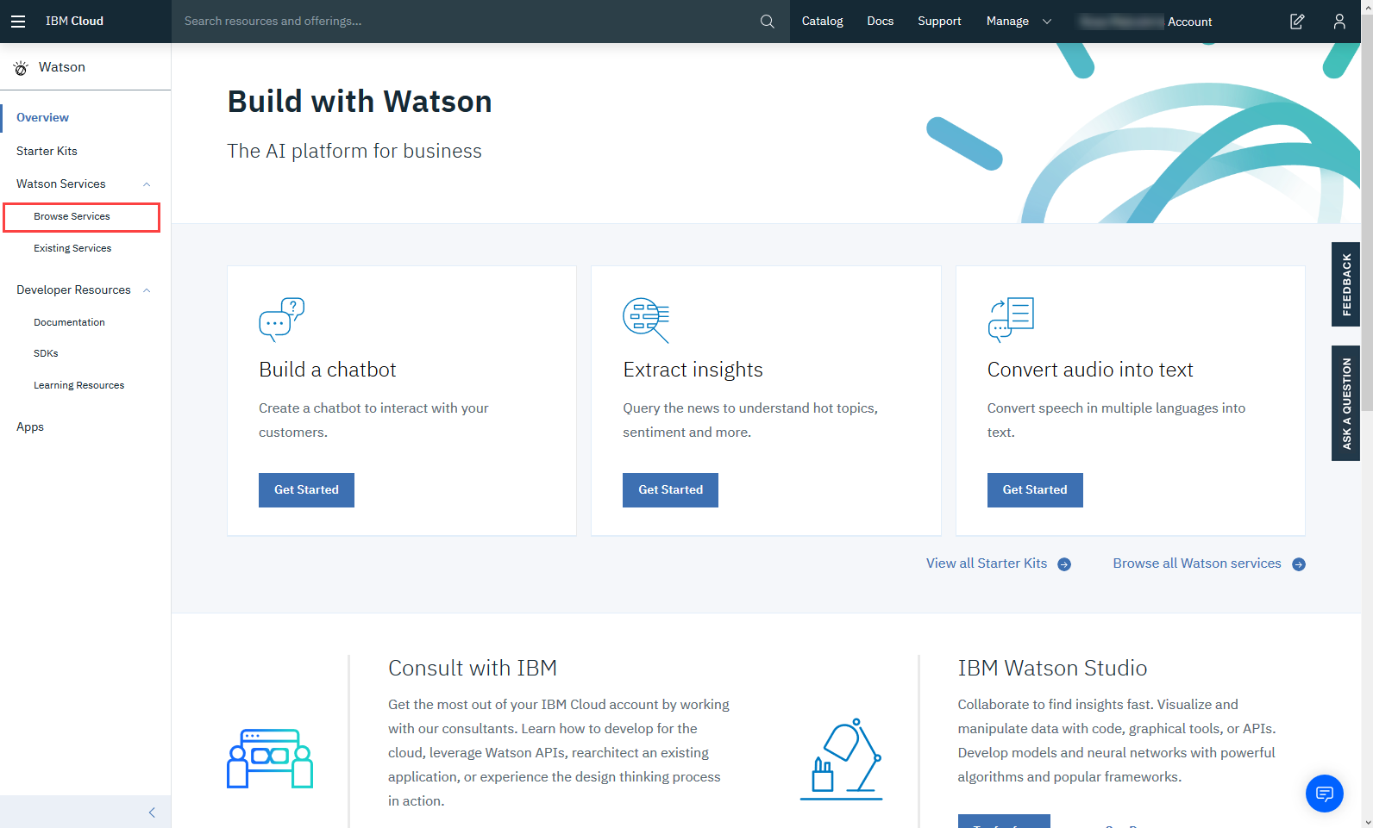

Scroll down and select **Watson Studio - Lite**.

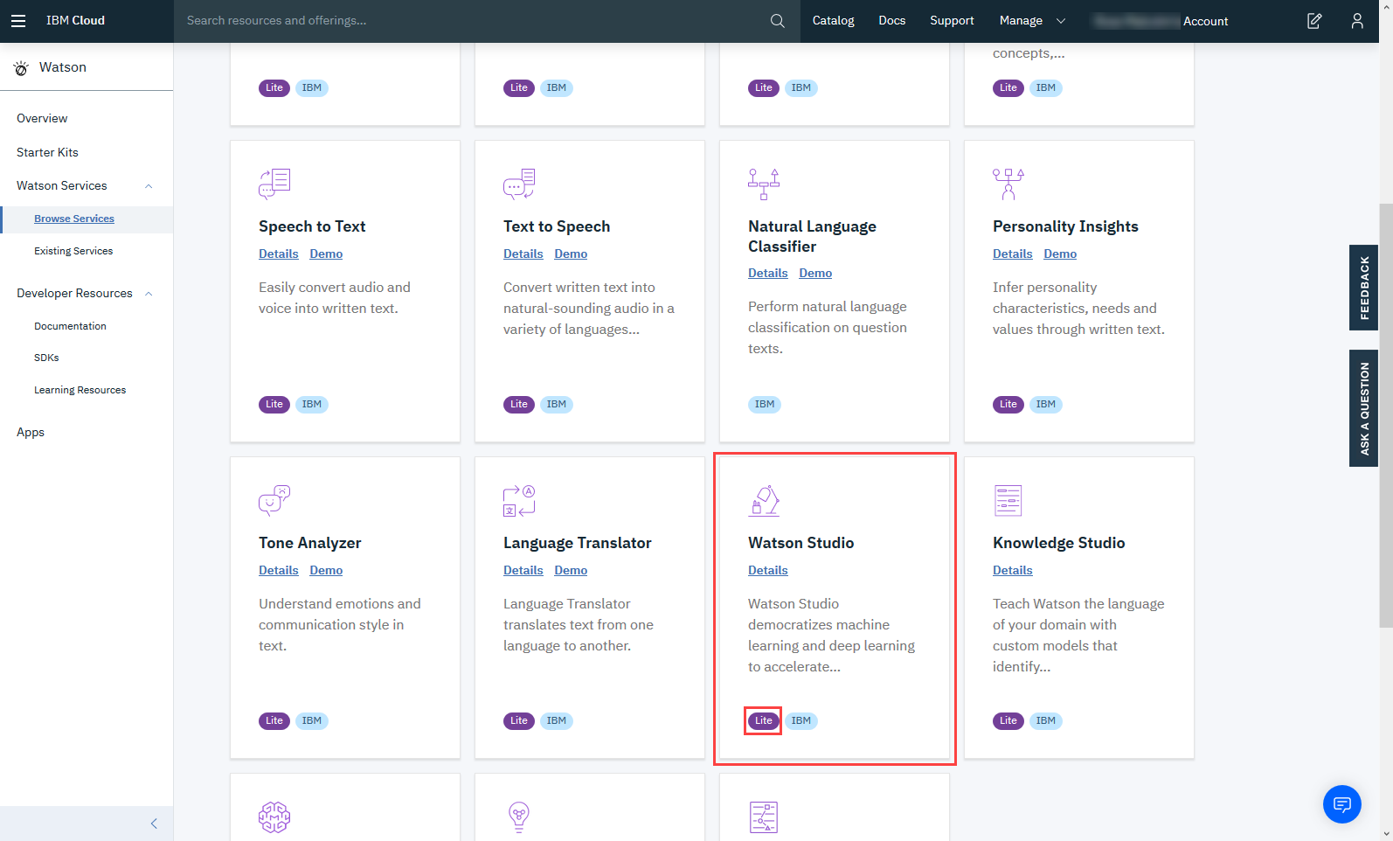

To create a Watson service using the Lite plan, click **Create**.

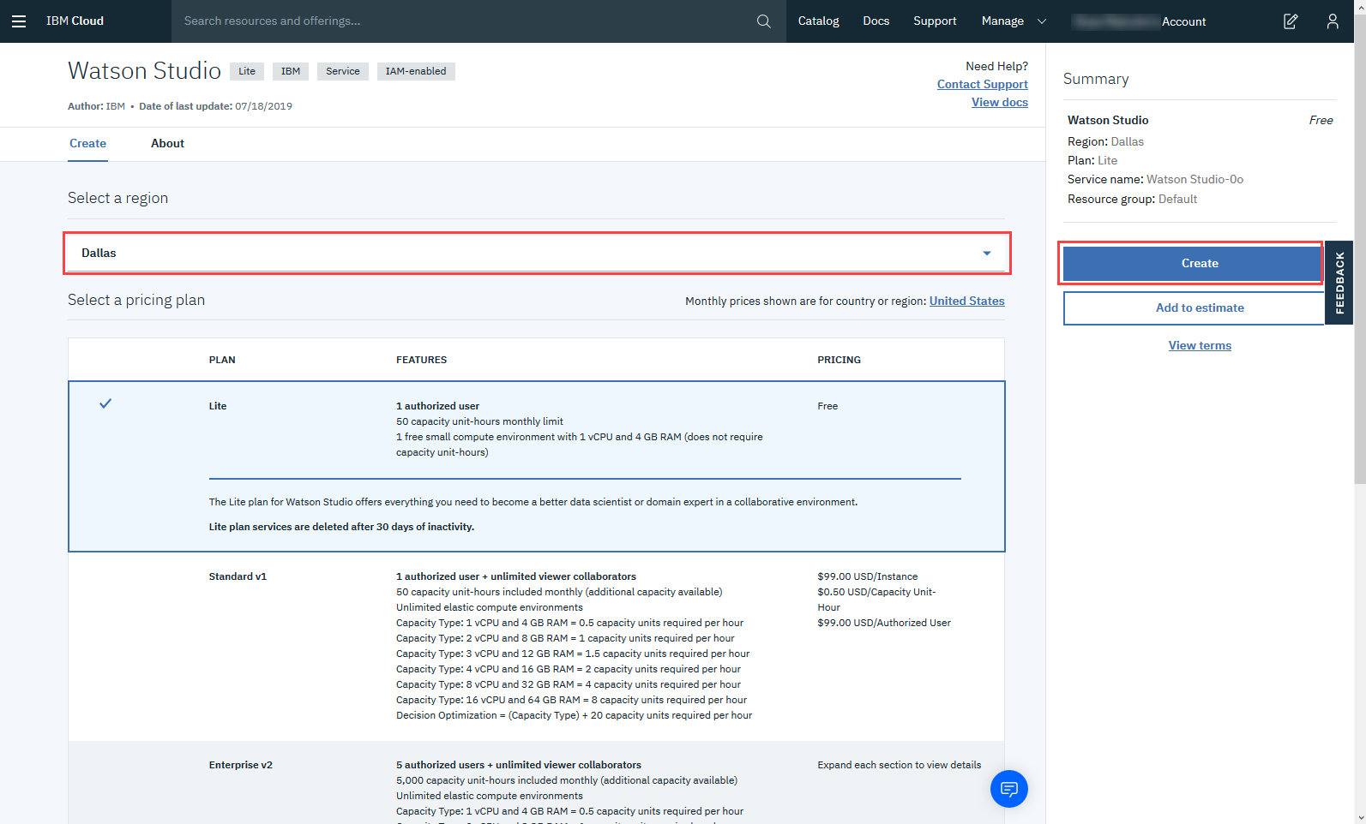

Now click **Get Started**.

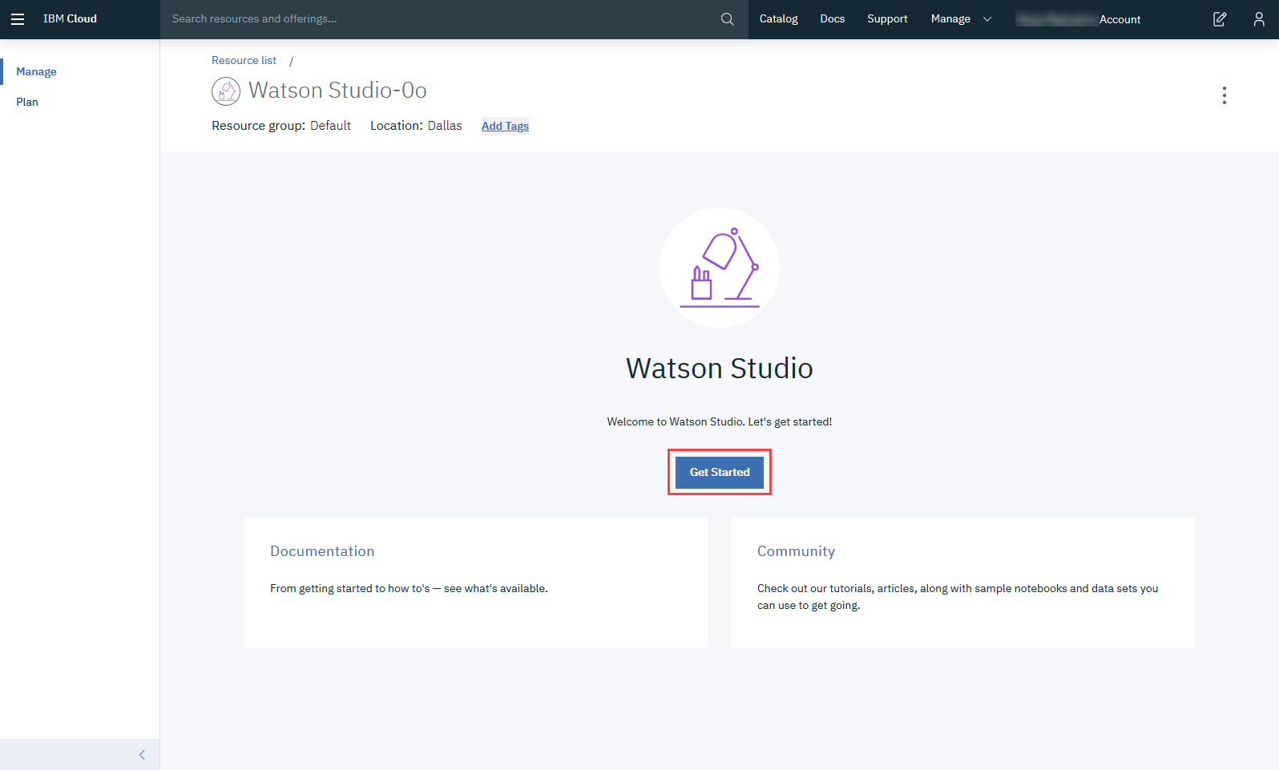

After creating the service continue with Step 2.

**Step 2: For Existing Users (who already have Watson Service):**

Go to the IBM Cloud Dashboard and click **Services**.

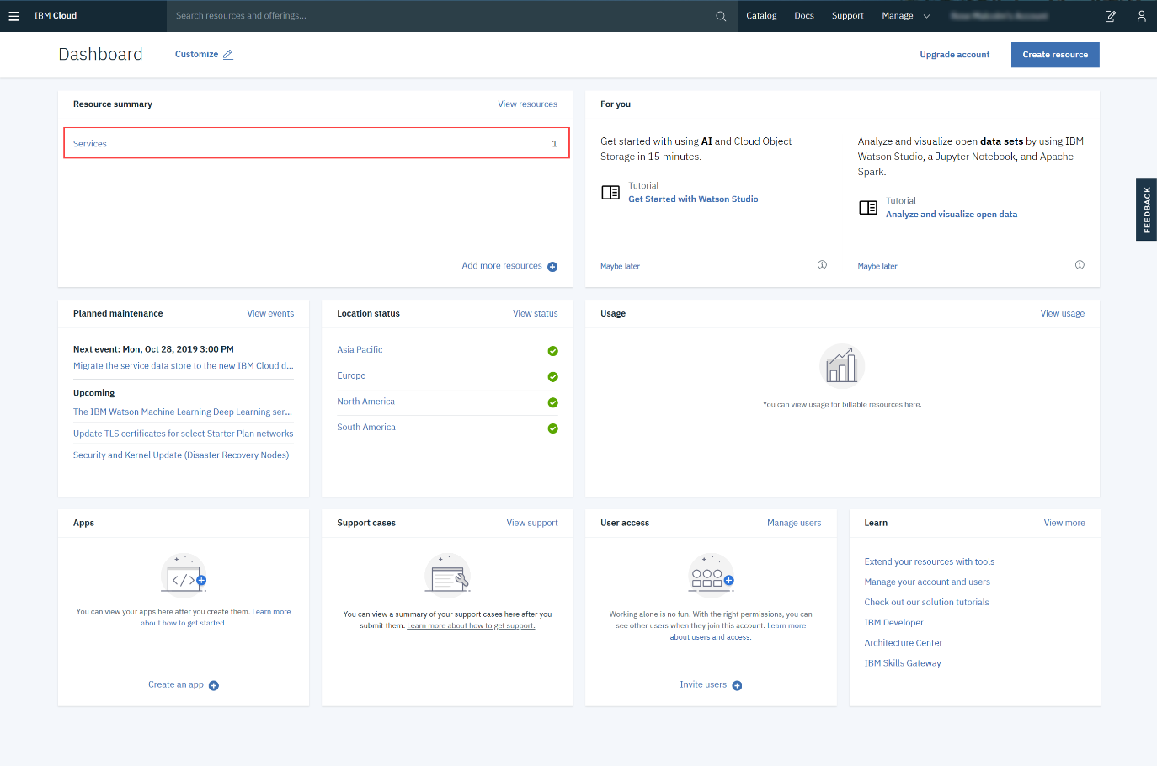

When you click on Services, all your existing services will be shown in the list. Click the **Watson Studio** service you created:

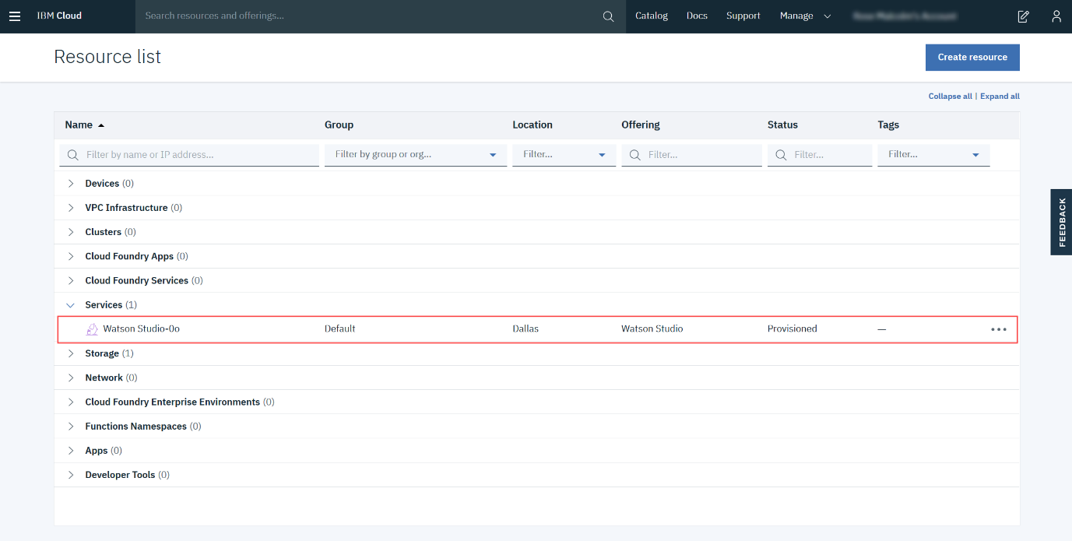

Then click **Get Started**.



**Step 3: Creating a Project**

Now you have to Create a project.  
  
Click on **Create a project**:

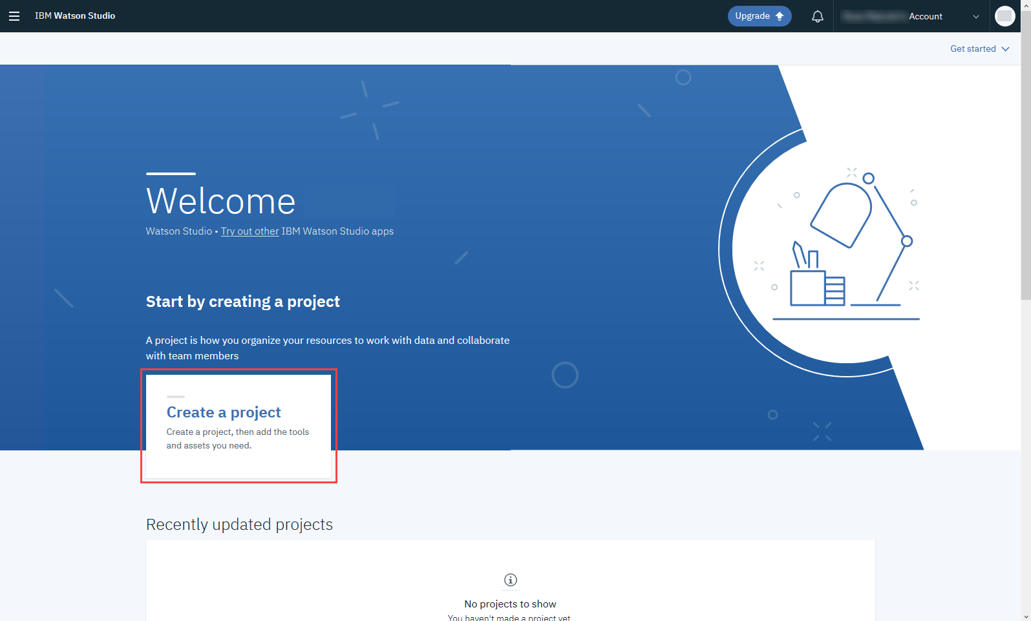

On the Create a project page, click **Create an empty project**

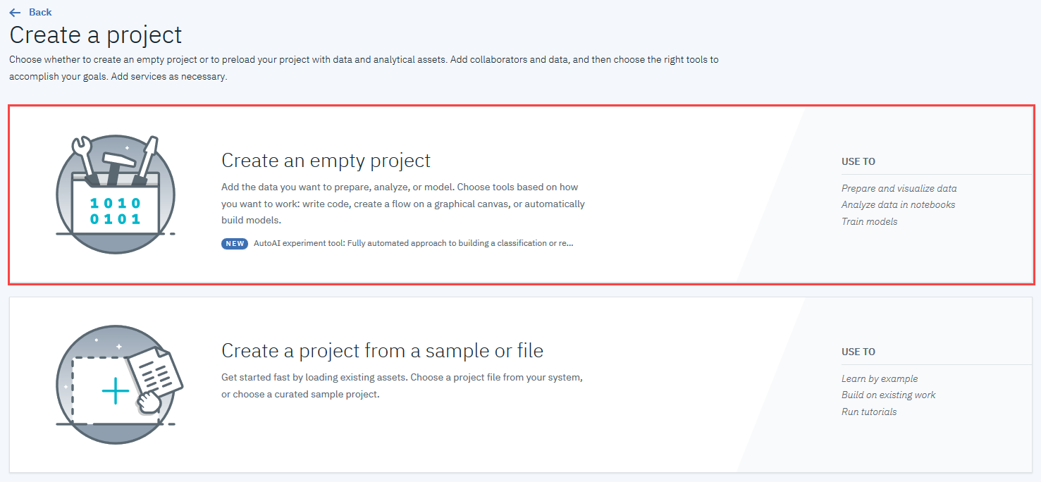

Provide a **Project Name** and **Description**, as shown below:

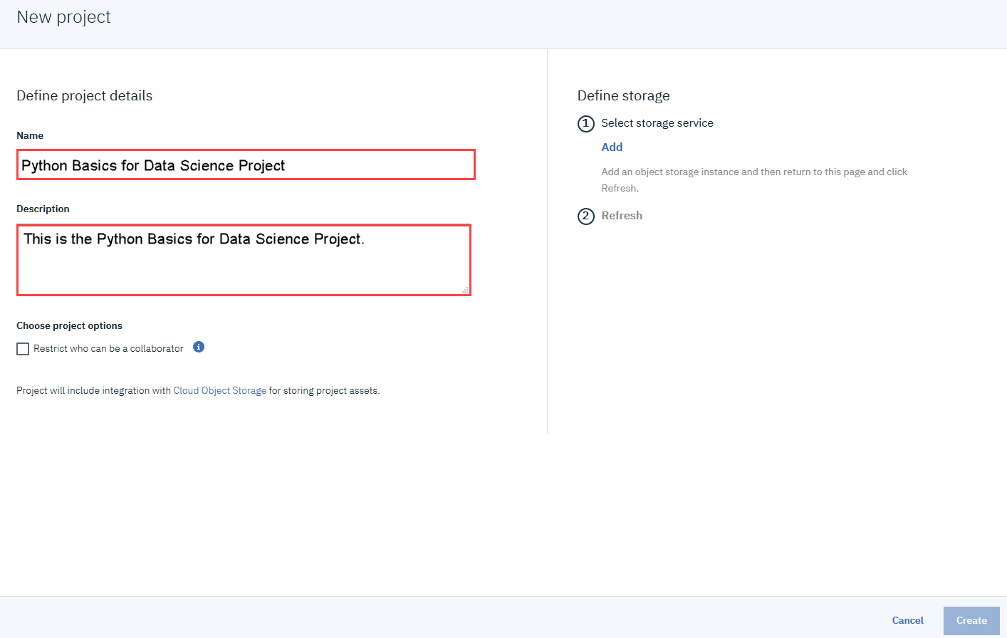

You must also create storage for the project.  
Click **Add**

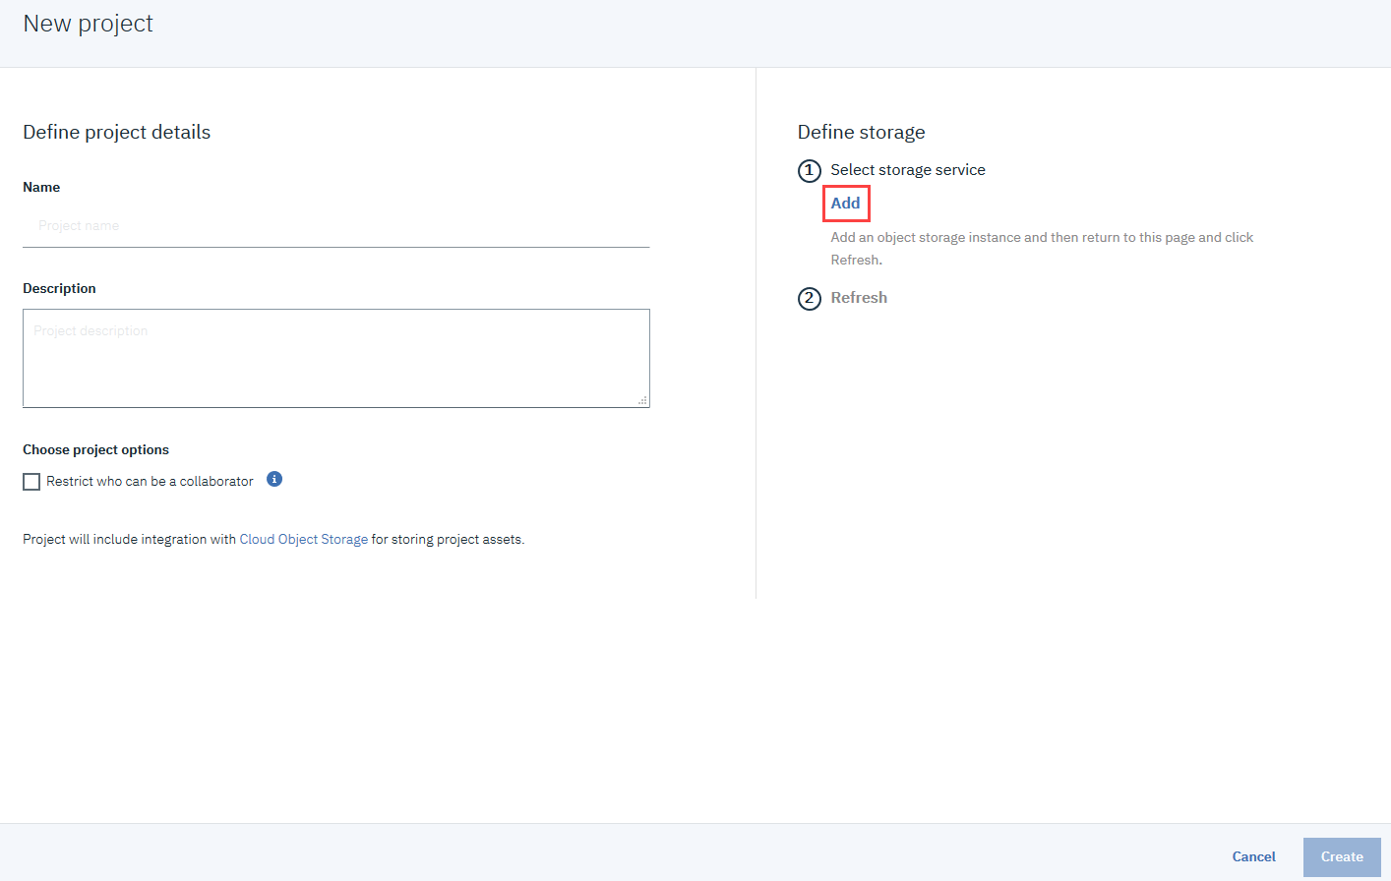

On the Cloud Object Storage page, scroll down and then click **Create**.

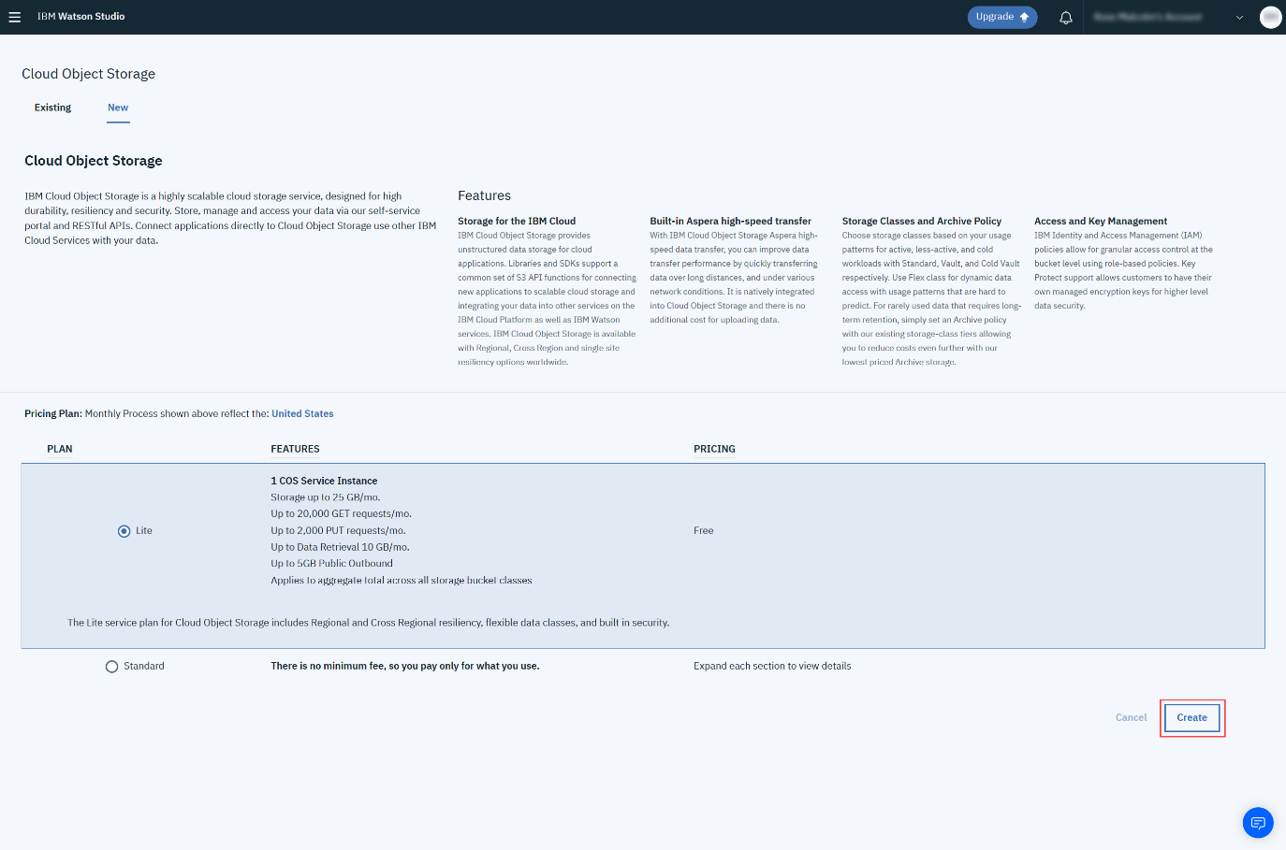

In the Confirm Creation box, click **Confirm**.

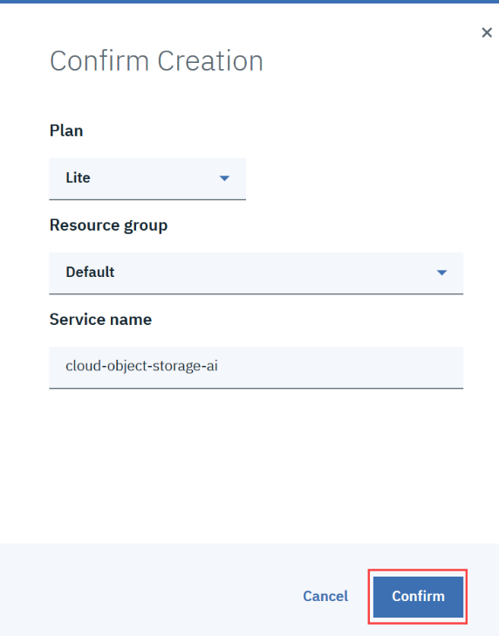

On the New project page, note that the storage has been added, and then click **Create**.

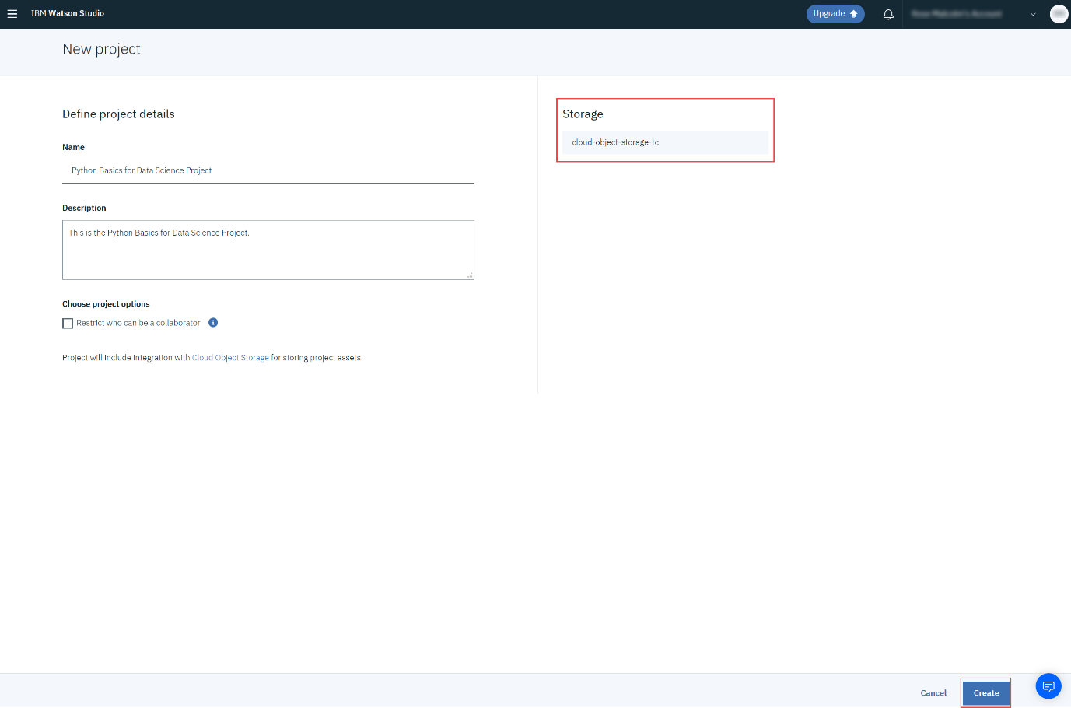

After creating the project continue with Step 3.

**Step 3: Adding a Notebook to the Project:**

You need to add a Notebook to your project. Click **Add to project**.

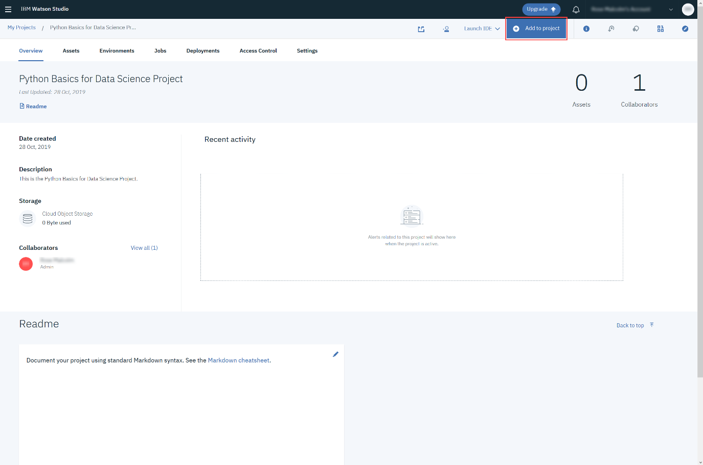

In the list of asset types, click **Notebook**:

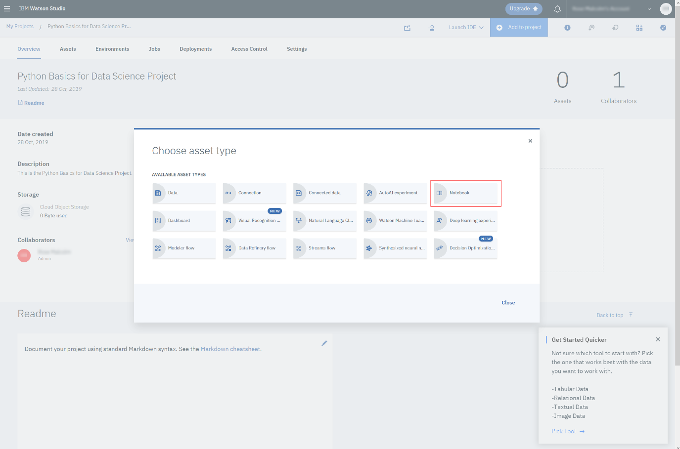

On the New Notebook page, enter a name for the notebook, and then click **From URL**.  
Copy this link:

[Click here](https://cocl.us/ML0101EXpog)

Paste it into the **Notebook URL** box, and then click **Create Notebook**.

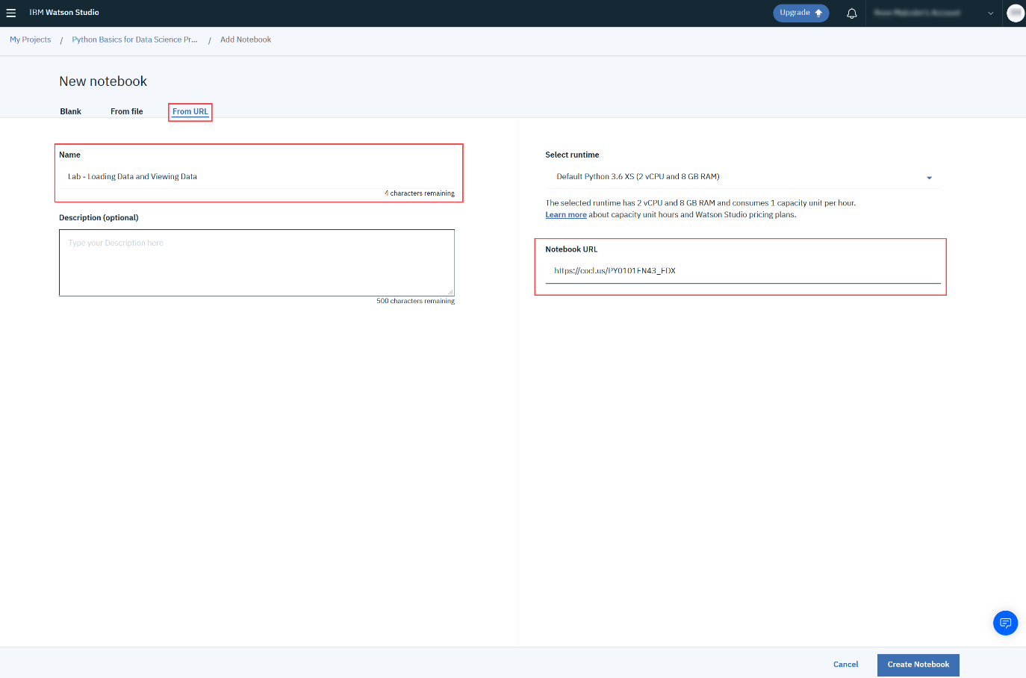

You will see this Notebook:

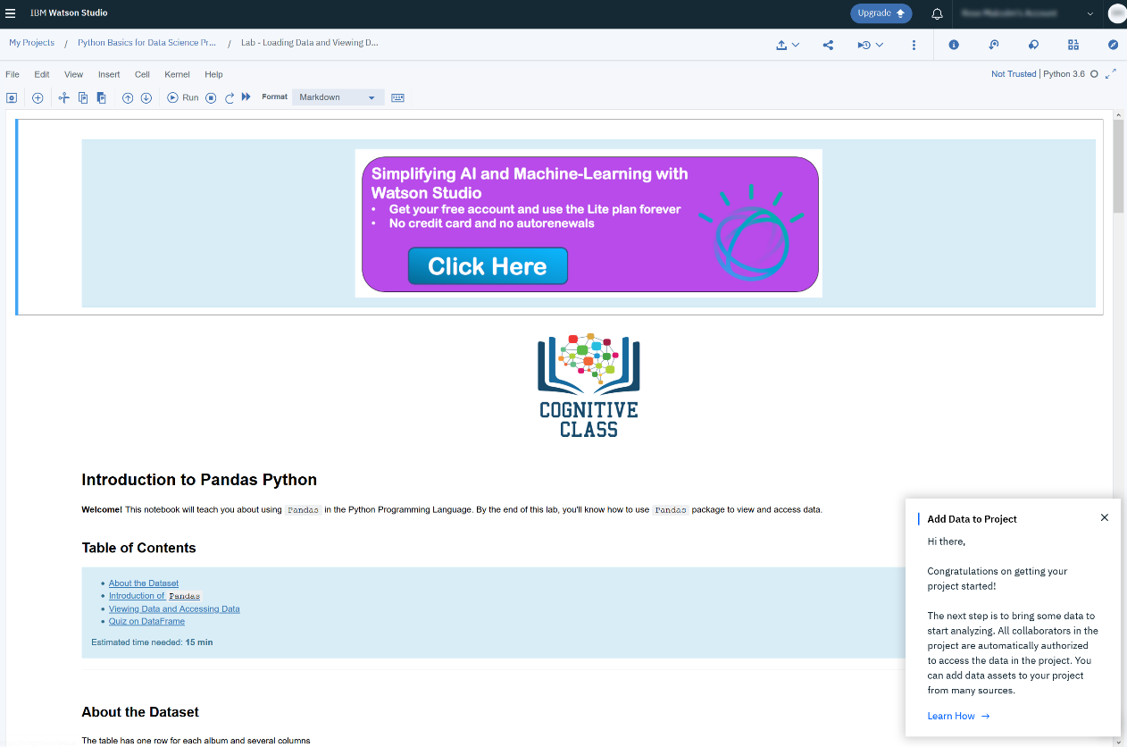

Once you complete your notebook you will have to share it. Select the icon on the top right a marked in red in the image below, a dialogue box should open, select the option all content excluding sensitive code cells.

